MEMTRAX – A Flexible Computer Game System for Assessing Cognitive and Brain Pathology Associated with TBI and for Augmenting and Monitoring Rehabilitation

● Background:

The proposal is designed to test two fundamental concepts. The first is that the cognitive deficits associated with traumatic brain injury (TBI) are common to specific brain injuries - especially local axonal shearing as described below. The second concept is that the key to rehabilitating a patient with TBI associated cognitive impairment is with intense cognitive stimulation directed toward the specific deficits being suffered. The specific aims outlined below will provide scientific proof of these concepts.

While there is no medication or direct intervention that can restore lost brain connections, there is evidence that neuroplasticity remains active and can be called into action for rehabilitation. Therefore, the key to rehabilitating a patient with TBI is intense cognitive stimulation directed at the specific deficits being suffered. The most practical approach to providing this kind of intense stimulation is by interactive computer exercises.

This project will first measure axonal brain injury in combat veterans with mild TBI using the approach of MRI brain scans with diffusion tensor imaging (MRI-DTI). Then we will provide the patients with one year of intense, prescriptive cognitive stimulation using the MEMTRAX system. Then we will rescan the subjects to measure improvement of axonal connectivity. MRI-DTI is currently considered the best approach to assay axonal shearing injuries in the brain, which may represent the most significant damage of mild TBI. Assessing changes in axonal connections with MRI-DTI could provide specific anatomical evidence of the benefit of cognitive rehabilitation. The technologies of scanning and computerized cognitive stimulation are thus harnessed together in a comprehensive program of rehabilitation.

Background of TBI:
As battle-field mortality has diminished due to body-armor, the survival of the brain has come into focus. Advances have been made in reducing acute mortality from TBI, but more progress is needed in the diagnosis of the chronic pathology associated with TBI, and there is a tremendous need to develop effective rehabilitation strategies for cognitive and behavioral problems that become chronic problems for those who have had TBI (Kim et al., 2007). One particular problem has been to understand the neurological deficits that underlie the chronic problems of TBI. It has long been considered that coup-contra-coup forces and focal cortical contusion damage of basal forebrain, including orbito-medial frontal cortex and medial temporal lobe structures are the critical problems. However, to date, high-resolution scanning techniques have not been adequate to show the substantial lesions associated with such chronic problems.

Recently, it has been suggested that diffuse axonal injury may explain a high proportion of the chronic problems in TBI patients (see Levine et al., 2006 for review). More recently, damage to discrete axonal tracts of the cerebral white matter has been linked to specific cognitive deficits (Taber & Hurley, 2007). The critical problem of vulnerability appears to be the difference in density between gray matter (90% water) and white matter (70% lipids). As blast waves or other concussion waves pass through the brain, a differential displacement of gray and white matter regions may occur. While small arterioles may be as small as 20 um and consist of fibrous walls resistant to tension, axons are 0.5 um at the largest, and have walls made of a fragile lipid bilayer with no significant tensile strength. In the gray matter, axons pass through a matrix of similar density supported by glial cells. In the white matter, axons are surrounded by the axolemma, that includes a thick sheath of myelin. However, there is no support for the axon as the point that it traverses the gray-white matter boundary. Consequently, if a shock wave displaced the gray matter as little as 1 um relative to the white matter, axons at this location would be sheared completely. Such shearing may be referred to as local axonal shearing, as opposed to diffuse axonal injury that has been considered in the literature.

With the development of the technique of MRI-DTI, it is now possible to visualize damage to specific axon tracts in patients with TBI (Nakayama et al., 2006) as well as mild cognitive impairment (Rose et al., 2006). Tractography can delineate specific axonal tracts that are potentially vulnerable to axonal shearing (Taber & Hurley, 2007), and the extent of local axonal shearing can be quantified and related to specific cognitive, behavioral, and neuropsychiatric problems. Further, shearing lesions at the gray-white matter interface may be focally localized and be related to the actual vector of force that caused the TBI.

To assess the loss of brain axonal connectivity associated with mild TBI, MRI-DTI appears to be the only approach that can provide information about the extent of the injury. Further, to determine whether intense cognitive rehabilitation directed at the impaired brain location, the most objective and reliable outcome measure would be to determine if improvement in axonal connectivity had occurred as measured using MRI-DTI.

Brain Neuroplasticity:
Critical periods are episodes during development when new connections are formed in the brain. For example, the primary visual area in the occipital cortex undergoes a critical period soon after birth when the primary afferent axonal pathways connect with appropriate neurons. Primary cortical areas undergo such connections early in life but still have some capability for forming new connections later (Wall & Kaas, 1985). Secondary cortical regions are also thought to undergo such critical periods during childhood, and then have limited capacity for altering connections later. However, tertiary cortical regions (higher association cerebral cortex) – including large areas of the frontal, temporal, and parietal lobes, have later periods of maturing and still maintain the capacity to form new connections throughout life. The frontal lobes do undergo a critical period in late adolescence and early adulthood (Feinberg, 1983), but the temporal lobes appear to maintain the capacity to change connections throughout life, to the extent that their neuroplasticity provides vulnerability to later life disease processes such as Alzheimer’s disease (Teter & Ashford, 2002). Of relevance to TBI, axons of the central nervous system are able to reestablish connections after damage (Aguayo, 1985). The continued neuroplasticity of associative cortical regions after maturity indicates their capacity to form new axonal connections and recover from the impairments of cognitive function caused by axonal-shearing deficits caused by TBI. Just as physical impairments related to neuronal dysfunction can frequently improve with intense rehabilitative therapy, this project is based on the presumption that more plastic higher cortical brain structures can similarly recover function with intense rehabilitative stimulation. The most objective and reliable approach available at this time to measure a change of axonal connectivity is MRI-DTI. A concern with the above formulation is that temporal and parietal areas may actually have more remaining plastic capability than the frontal lobes, so cognitive rehabilitation may be more successful than rehabilitation of thinking and personality deficits.

MEMTRAX System for Cognitive Assessment and Rehabilitation:
MEMTRAX is an internet-server based system to be accessed by computers using a web-browser for testing cognitive function and rehabilitating cognitive deficits. The core MEMTRAX programs for testing cognitive functions consist of the presentation of a sequence of images and the measurement of the response of pressing the keyboard space-bar. Programs to run the test have been written using several computer-based and web-browsing languages (e.g., FLASH, HTML, Javascript, JAVA, PERL, C++). Images are generated by digital photography and/or computer-design. MEMTRAX was initially used for testing retentive memory and screening elderly individuals for dementia, and it compared favorably to numerous longer screening tests in a systematic study (see: Brodaty et al., 2006 - as the Bowles-Langley Technology / Ashford Memory Test). Testing is easy and fun, while being highly flexible, so it can potentially assess many cognitive functions. MEMTRAX can be adapted to assess highly specific cognitive functions by adjusting the pictures and the response contingencies. Accordingly, the test has the potential to examine and determine the specific deficits found in any individual TBI patient. Test images and contingencies targeting specific deficits can serve as a fun video game. This system can be supplemented with a broad variety of available and developing computer-based mental exercises and video games so that even impaired patients will play eagerly for prolonged sessions each day, and rehabilitate and develop their cognitive impairments associated with TBI.

To supplement the core MEMTRAX program and provide optimal cognitive stimulation for brain rehabilitation, plans are being developed to incorporporate a broad assortment of additional assessment tools (including attention tests developed by Bowles-Langley Technology and others assembled by Cognitive Labs) as well as cognitively stimulating interactions targeting prescriptively the deficits of individual patients. Such cognitive stimulation will include the unlimited resources of puzzles and games available for personal computers and on the internet. The MEMTRAX system will be expanded to include all computerized stimulation - training, exercising, gaming - that is considered to be potentially beneficial for TBI patients. Also under development are collaborations with “Bright-Minds-Institute” (see letter of support), which develops computerized learning methods for children, and PositScience (see letter of support), both of San Francisco, which has developed some specific rehabilitation tasks to improve brain functioning (personal communication, Zelinsky et al., Gerontological Society of America, 2007).

To maximize the technical performance of MEMTRAX, SRI International has offered to provide additional development and implementation assistance to strengthen the functionality of this system. PriceWaterhouse Cooper will coordinate, supervise, and monitor the progress of MEMTRAX development in the private sector. Their coordination will provide a structure that will foster the optimal development and reliability of the MEMTRAX system. Together, these two organizations will assure the provision of optimal rehabilitation to the veterans.

Brain Assessment Approaches Including MRI-DTI:
Conventional radiological study of patients with the post-concussion syndrome may reveal few or no abnormalities, and metabolic and blood-flow imaging studies generally provide little or no indication of loss of cerebral functional activity. Similarly, the major structural changes of more severe injury provide little insight regarding accompanying impairment of brain function. Thus, the identification of markers of neurological function which may permit more precise diagnosis, and enhanced evaluation of the response to treatment and of recovery prediction, must be sought elsewhere.
a) Diffusion tensor imaging (MRI-DTI): MRI-DTI (Basser, 1994) represents an advance over older diffusion weighted imaging techniques, which provided a spatially averaged apparent diffusion coefficient (ADC), not specific for tissue structures. In contrast, MRI-DTI can, in addition, characterize the directionality of water diffusion in 3-dimensional space, providing more specific information. Within coherently organized white matter tracts with parallel fiber bundles, water diffuses more freely along the direction of the white matter fibers than across the fibers, since diffusion orthogonal to the fibers is impeded by structural elements such as the myelin sheath of axons and their plasma membranes, the axolemma. This phenomenon is known as diffusion anisotropy, and can be quantified within white matter tracts using MRI-DTI. The most commonly used metric is fractional anisotropy (FA) (Abe, 2006), which ranges in value from zero (i.e., perfectly isotropic diffusion) to one (i.e., perfectly linear diffusion). Recent MRI-DTI studies have shown that FA is reduced at sites of traumatic axonal shearing injury, corresponding to a loss of microstructural fiber integrity, resulting in the reduced directionality of microscopic water motion (Arfanakis, 2002; Huisman, 2004). While an increasing number of MRI-DTI studies in traumatic brain injury are emerging (Naganawa, 2004; Inglese, 2005; Ducreux, 2005; Ewing-Cobbs, 2006; Le, 2005; Nakayama, 2006; Niogi et al., 2007; Salmond, 2006; Tisserand, 2006; Xu, 2007; Benson, 2007), so far, very few studies on the possible relationships between MRI-DTI findings and neurocognition have been undertaken (Salmond, 2006; Niogi et al., 2007), and no data concerning the specific impact of military brain injury (blast or impact injury) on the integrity of white matter tracts are currently available.
b) Susceptibility-weighted MR imaging (SWI): Recently, SWI, originally designed for MR venography by using the paramagnetic property of intravascular deoxyhemoglobin, has been introduced (Reichenbach et al., 1997; Haacke, et al., 2004}. Based on a high-spatial-resolution three-dimensional gradient-echo technique, SWI is extremely sensitive to local susceptibility changes and can be performed with conventional MRI instrumentation. Very recently, the SWI technique has been applied on a clinical 1.5 T MRI scanner in several studies of pediatric traumatic brain injury (Babikian et al., 2005; Tong et al., 2003a; 2003b; 2004). These studies demonstrated that SWI allows detection of hemorrhagic lesions in brain-injured children with significantly higher sensitivity than conventional gradient-echo MR imaging (Tong et al., 2003a). The number and volume of hemorrhagic lesions was shown to correlate with the Glasgow Coma Scale score (Tong et al., 2003b), as well as with other clinical measures of TBI severity, and with outcome at 6 to 12 months post-injury (Tong et al., 2004). Significant differences were detected between children with normal outcome or mild disability and children with moderate or severe disability when comparing regional injury to clinical variables (Tong, et al., 2004). In addition, negative correlations between lesion number and volume with measures of neuropsychologic functioning at 1-4 years post-injury were demonstrated (Babikian et al., 2005. No parallel studies in adult brain injury have been reported, and there are currently no SWI data available from subjects who have suffered a traumatic brain injury by either blast or impact during combat.
c) Perfusion-weighted MR imaging (pMRI): While dynamic contrast enhanced pMRI of TBI patients has shown that regions of both normal appearing and contused brain may have an abnormal regional cerebral blood volume (rCBV) and that alterations in rCBV may play a role in determining the clinical outcome of patients (Garnett et al., 2001), no studies using arterial spin labeling (ASL) pMRI in TBI have been published so far. Taken together, these imaging studies imply that TBI is associated with a range of structural, functional, and metabolic alterations.

Preliminary Results:
Figure 1: Subfield marking scheme
a) Quantitative parcellation of hippocampal subfields: A high resolutionT2 weighted fast spin echo sequence was acquired for manual marking of hippocampal subfields (acquisition and processing methods described in our publication (Mueller et al., 2006}). The hippocampal subfields, ERC, subiculum, CA1, CA1&CA2 transition zone (CA1&CA2), CA& dentate gyrus (CA3&DG), were marked on 5 consecutive slices. (Mueller et al., 2006) (Fig. 1).

b) Segmentation/Voxel-based-morphometry: T1 weighted image were acquired using a magnetization prepared rapid gradient echo sequence (TR/TE 2300/3.37 ms, TI 950 ms, 176 slices, resolution 1x1x1 mm) for single channel segmentation using Expectation Maximization Segmentation (EMS) algorithm (Van Leemput, et al., 1999a;b). For VBM, the gray matter maps in subject space obtained from EMS were normalized to a customized but not project specific gray matter prior. An 8 mm FWHM Gaussian smoothing kernel was applied to all gray matter maps (Fig. 2).
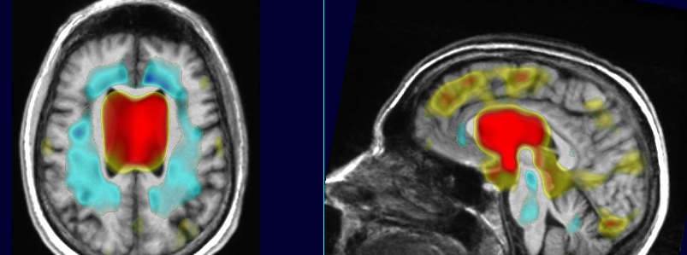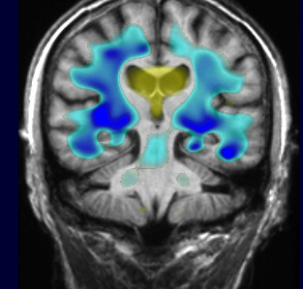
Figure 2: The two left panels show effects of age; the right panels shows regions where AD patients have tissue atrophy compared to controls (blue).

c) Arterial Spin Labeling perfusion-weighted MRI (ASL pMRI): For measurement of cerebral blood flow in resting state, a continuous arterial spin labeling sequence (TR/TE 5200/9 ms, delay in TR 1590 ms, 80 measurements, resolution: 5.0 x 3.8 x 5.0 mm, 16 slices) was acquired. Subjects were resting quietly with their eyes closed. Correction for partial volume effects between tissue/csf was performed by dividing the tagged and un-tagged image with a tissue probability map (gray and white matter probability maps derived from EMS) Finally, gray matter CBF was obtained by subtracting CBF measured in deep white matter regions (centrum semiovale) (Muller-Gartner et al., 1992). Statistical analysis was performed using statistical parametric mapping (SPM) (Fig. 3).
Figure 3: CBF map before (left) and after partial volume correction (right).

d) Diffusion Tensor Imaging (MRI-DTI): MRI-DTI was acquired using an echo planar imaging (EPI) sequence (TR/TE 6000/77 ms, GRAPPA acceleration factor 2, b = 800 s/mm², 2 x 2 x 3 mm, 40 slices, and 6 diffusion sensitization directions). After motion correction, fractional anisotropy (FA), mean diffusivity (MD), maps were calculated offline using DTIstudio and Volume-One (Jiang et al., 2006; Masutani et al., 2003). The FA map was used to identify the cingulum (FA threshold 0.18) and corpus callosum. In addition to this, voxel based analysis, was performed using tract based spatial statistics (TBSS) (Smith et al., 2006) or SPM. More preliminary studies with MRI-DTI are outlined below.
e) Cortical Thickness Measurements with Freesurfer: The T1 weighted images were bias corrected using the bias field provided by EMS and loaded into the FreeSurfer {http://surfer.nmr.mgh.harvard.edu/ #13} software package for calculation of cortical thickness and parcellation into different cortical and subcortical region. The hippocampal labels of the latter were extracted, manually edited and used to calculate total hippocampal volumes (Fig. 4).
Figure 4: (a) Cortical thickness measurement and parcellation in a 66-year-old Alzheimer’s patient. (b) Hippocampal labels derived from the parcellation were used to calculate total hippocampal volume.

f) Susceptibility-weighted MR imaging (SWI): SWI (Haacke et al., 2004) has been implemented on the 4 Tesla MRI magnet at the CIND. Extensive experience with acquisition, processing, and analysis of SWI data, as well as software for these tasks, is available in Dr. Weiner’s lab. Preliminary data obtained with this method are shown in Fig. 5. This demonstrates the ability of the SWI technique to detect small hemorrhagic lesions, such as those occurring in cerebral amyloid angiopathy (see arrows in Fig. 5) and in traumatic brain injury.

Figure 5: Structural MR image (a) and susceptibility-weighted MR images (b-d), representing three orthogonal sections through a hemorrhagic lesion (arrows), acquired at 4 Tesla from a patient suffering from cerebral amyloid angiopathy.

g) Effects of Mild Cognitive Impairment (MCI) and Alzheimer’s Disease (AD): Subfield measurements and total hippocampal volumes were available for 14 AD, 14 MCI and 47 age-matched control subjects. Compared to controls, AD had significantly smaller volumes of ERC, subiculum, CA1, CA1-2 transition, and total hippocampal volumes, and MCI had smaller CA1 and CA1-2 transition volumes (Table 1).
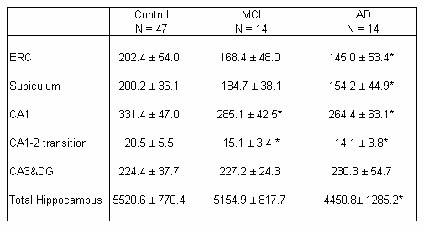
Table 1: volumes in mm³; *, significant p<0.05 than controls.

The patterns of subfield atrophy in AD and MCI are consistent with patterns of neuronal cell loss/reduced synaptic density described in histopathological studies. Discriminant analysis and power analysis showed that CA1-2 transition, i.e. the region in the dorsal medial aspect of the hippocampus, was superior to total hippocampal volume for distinction between controls and subjects diagnosed with MCI.

These preliminary findings suggest that hippocampal subfield volumetry is superior to total hippocampal volume as a measure for diagnosis of very early AD. Cortical thickness measurements using FreeSurfer (13 AD, 57 controls) showed significant reductions in the region of ERC, temporo-lateral, precuneus, parietal, and frontal (Fig. 6 a). Perfusion measurements showed CBF in the precuneus and parietal and temporal in AD (6 AD, 26 controls) (Fig. 6b). A similar but milder pattern of hypoperfusion was found in MCI (Fig. 6c).
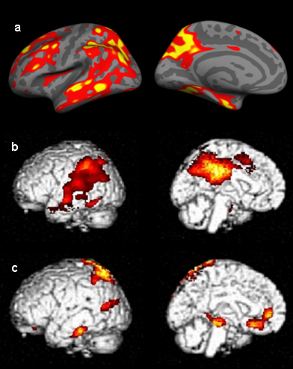
Voxel-based MRI-DTI analysis using TBSS showed FA reductions in parietal and posterior cingulate white matter, similar to our published work at 1.5 Tesla (Zhang et al., 2007). We also found FA reductions in frontal WM consistent with frontal higher white matter lesion load in AD compared to controls.

Figure 6: Gray matter loss and hypoper-fusion in AD and MCI.
h) MRI-DTI fractional anisotropy and tractography applied to specific clinical cases:
There have been several hundred patients with TBI who have been assessed recently at the VA Palo Alto Health Care System (VAPAHCS); (about 150 per year since onset of OIF/OEF). The VAPAHCS War Related Illness and Injury Study Center (WRIISC) program will conduct an inventory of these patients and determine their status. Several cases from the VAPAHCS have already been evaluated at the San Francisco Veterans Affairs Medical Center (SFVAMC).

To demonstrate the resources available at the VAPAHCS and SFVAMC, there is a case of a 24 year old patient who was still active-duty military. Though he survived the explosion of an improvised explosive device in Iraq and suffered 10 minutes of unconsciousness, he was scheduled to return to Iraq. The 1.5T MRI and the PET/CT was read as normal. He was thoroughly evaluated by the Speech Pathology Service and found to have conduction aphasia that was questioned as relevant or significant for his return to active duty. On referral to the SFVAMC, loss of volume in the arcuate fasciculus, which connects Wernicke’s and Broca’s areas on the Left side of the brain was discovered. Retrospective analysis of the MRI and PET scans showed abnormalities.

Firgure 7: 4T-MRI with MRI-DTI imaging
25 y/o control 24 y/o patient
Left anterior Left posterior Left anterior Left posterior
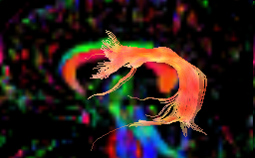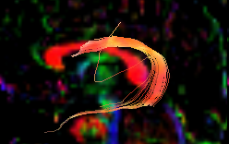
Arcuate fasciculus in orange. Note abrupt termination anteriorly (Right), may be related to fractional anisotropy, likely due to loss of fiber integrity. One possible causal explanation is local axon shearing.

PET 1.5T-MRI
Right Left Right Left
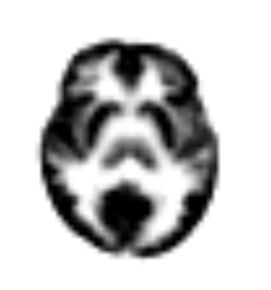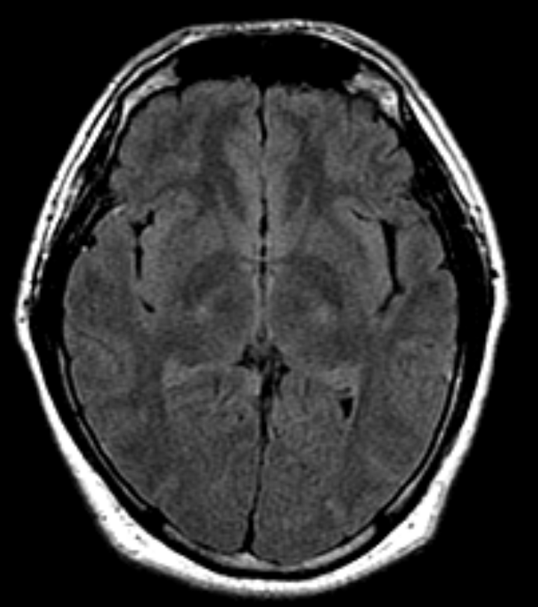
PET and MRI were both read as normal, but there is decreased activity seen on the PET scan in the Left frontal region near Broca’s area and there is apparent atrophy in this region on the MRI.
Figure 8: Other Brain Circuits Measured with MRI-DTI: Fronto-temporal paralimbic circuit (uncinate fasciculus, pink) and anterior corpus callosum (yellow) in a patient with fronto-temporal dementia (71 y/o, left), which is frequently accompanied by disinhibition, apathy, and altered social regulation. (Control 70 y/o on Right). Green represents the visual radiations (from lateral geniculate to striate cortex).

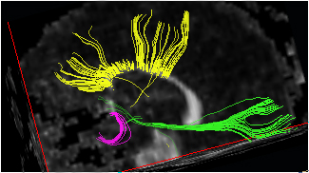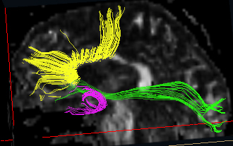

Figure 9: Shows various parts of the corpus callosum, with less fractional anisotropy in the older subject
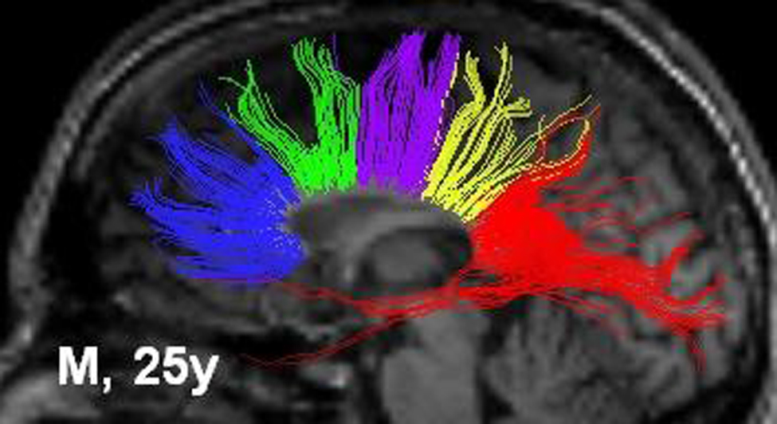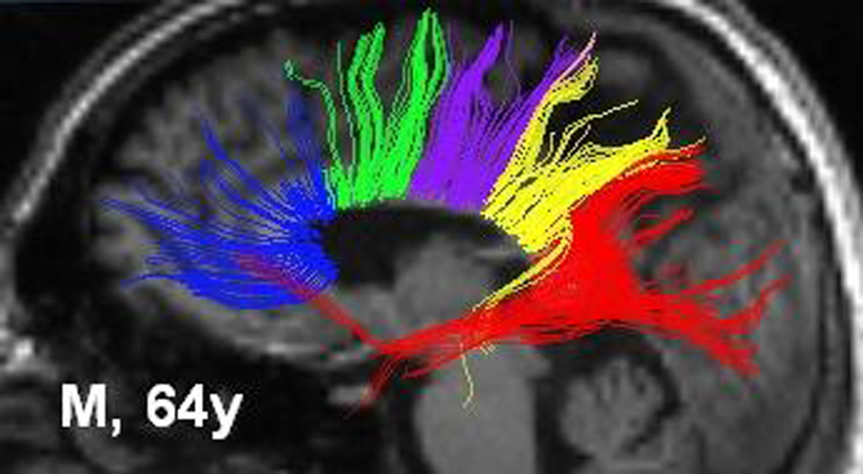

Figure 10: Disorder specific MRI-DTI changes: PTSD: DTI by SPM2 - Fractional Anisotropy ~ Group+age: 10 male vets without PTSD, 11 with PTSD, 43.5±17.7; 43.6 ± 14.0 years old.
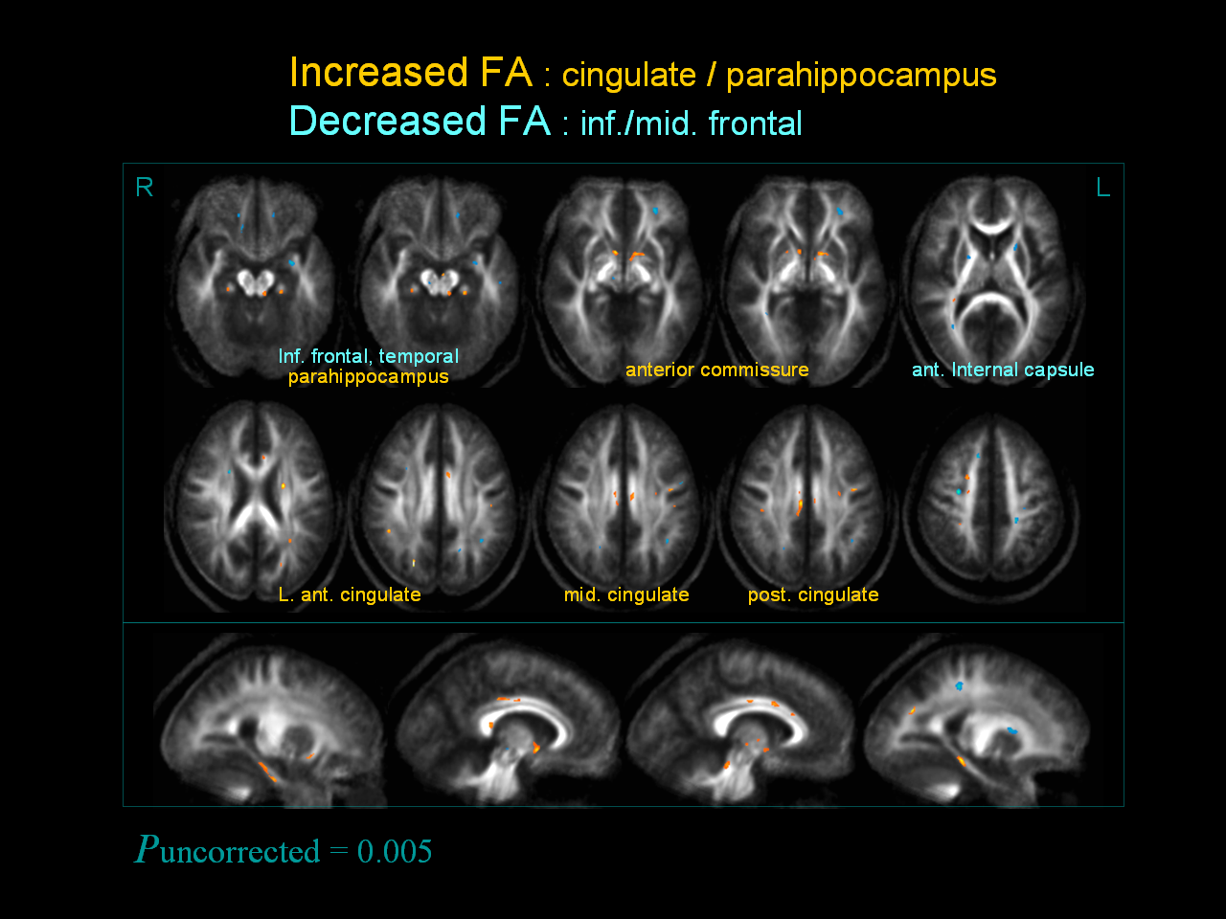
i) MEMTRAX clinical experience:
The MEMTRAX screen, as a series of 50 pictures, 25 repeated, 5 seconds per picture, and paper-form response, has been given to over seven hundred subjects. The performance of each item was studied in a preliminary sample of 116 elderly subjects who took the test anonymously as part of their participation inn a presentation on Alzheimer’s disease. In this group, 5 subjects were significantly impaired in recognizing the pictures, 4 had borderline difficulty with correct recognition, and 3 subjects made an excess number of inappropriate responses (reporting more than 5 pictures as repeats falsely). Consistent variation was noted in the scores on individual pictures, related to similarity to other pictures and visual uniqueness (Ashford, 2007). Figure 10:

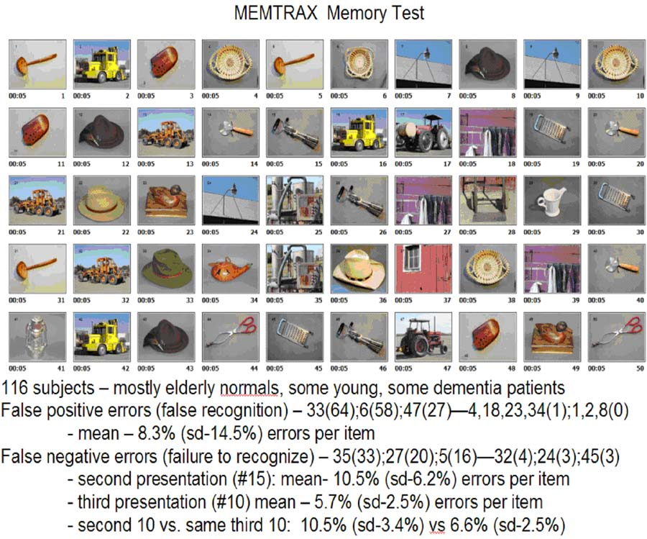

j) Metabolic brain image analysis:
SPECT images from Alzheimer patients were analyzed with a cortical surface mapping program. Surface values had high correlation with severity in regions following a pattern essentially identical to the known distribution of Alzheimer pathology (Ashford et al., 2000). Figure 11:

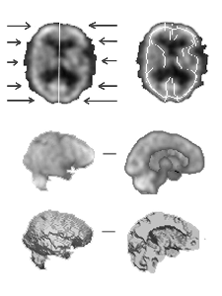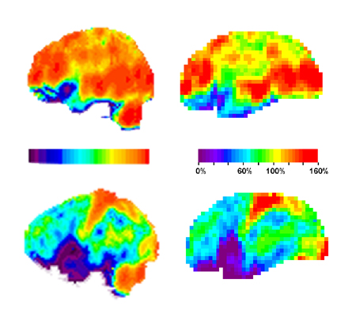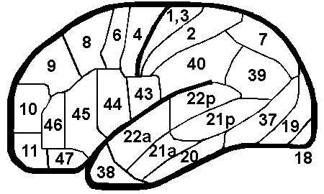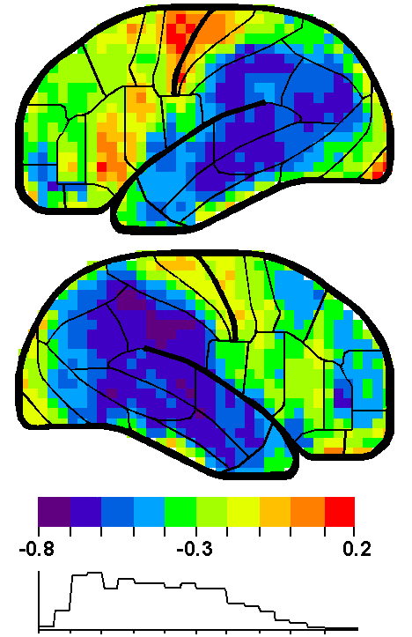

A similar, but more advanced dimensionally, cortical surface analysis approach will be used for comparing the PET data with the MRI-DTI indicators of axonal disconnection.
● Hypothesis and Objective:

The central thesis of this study is that intensive cognitive stimulation for one year will increase the measured connectivity in the injured cerebral circuits in patients with mild traumatic brain injury (TBI) associated with limited neuropsychogical deficits, and related to localized injuries in specific cerebral axonal pathways.

The main objectives of this proposal are:
- to determine the utility of MRI-DTI as a central tool for determining brain changes secondary to TBI that explain the common, diffuse neuropsychological and cognitive problems found in these patients,
- to coordinate an assortment of computerized cognitive assessments, training programs, cognitive rehabilitation tools, and brain-enhancing entertainment systems to optimally activate the damaged brain mechanisms, as uniquely determined for each patient, and
- determine if the participation in the computer interactions is associated with improvements in the injured cerebral pathways.

The specific hypotheses to be tested are as follows:

Hypothesis 1: In mild TBI patients, axonal damage seen on MRI-DTI will correspond to neuropsychological, speech & language deficits, the pattern of brain metabolism, and variations in neurophysiological activity.

Hypothesis 2: After one year of intense prescriptive cognitive rehabilitation directed at those deficits, beneficial changes will be seen in axonal connectivity indicated by MRI-DTI

Hypothesis 3: After 1 year, axonal connectivity changes seen on MRI-DTI will correspond with changes seen on follow-up neuropsychological testing, speech & language assessment, changes in brain metabolism, and neurophysiological activity.

Hypothesis 4: Improvements in all basic measures will correspond with improvements in ADL function and QOL indicators

Numerous secondary hypotheses will be tested, including the following:
- MRI-DTI indicators of axonal injury will occur in regions of the brain indicated as dysfunctional by other assessment modalities, including neuropsychological testing, speech & language assessment, PET brain metabolism using high resolution coregistration with CT and MRI, and electrophysiological measures, including quantitative EEG and event-related potential (ERP) parameters.
- After one year, improvements in MRI-DTI connectivity will be reflected by improvements in neuropsychological testing and speech & language assessment measures, PET metabolism, and electrophysiological indices.
- EEG/ERP measures at baseline will predict the degree of recovery after one year and improvements in the EEG/ERP parameters will correspond to the improvements seen in the other modalities.

● Specific Aims:

The specific aims of this project are in two parts, those that address the measurement of the brain injury and those that address the cognitive rehabilitation:

1) Determine the relationship between local axonal shearing as measured on MRI-DTI scans and cognitive dysfunction:
MRI-DTI scans will be obtained in 100 mild TBI cases (20 - 50 years of age), 50 normal age-range matched controls, and 50 moderate TBI cases (20 - 50 years of age), all of whom will have complete medical evaluations including neuropsychological testing, speech & language assessment, PET/CT scans, EEG/ERP measures. Further MRI studies will include SWI and perfusion assessments. This project will determine the relationship between axonal impairments seen in MRI-DTI scans and the other measures of brain function.

2) Determine whether one year of intense cognitive-rehabilitation will enhance connectivity of brain regions where axonal shearing occurred or in areas subserving similar functions to those areas where axonal shearing occurred:

Cognitive rehabilitation methodology will be coordinated and applied to 75 mild TBI cases, 25 moderate TBI cases, and 25 normal individuals, while placebo (no additional or specific therapy) will be provided to 25 mild TBI cases, 25 moderate TBI patients, and 25 normal individuals. The MEMTRAX test will be expanded to evaluate and meet the needs and deficits of each of the TBI patients, for neurocognitive assessment, tracking recovery, and rehabilitative training. The efficacy of the MEMTRAX system for TBI rehabilitation will be primarily assessed with assessment of change on the MRI-DTI scans obtained after one year of treatment. Secondary measures will include comparison of performance on specific aspects of this tool with brain imaging – PET/CT, MRI (anatomic measures, SWI, perfusion), fMRI, as well as neuropsychological testing and speech & language assessment, and quantitative EEG and ERPs.

3) Determine whether one year of intense cognitive-rehabilitation provides benefit to TBI patients on any other measures of brain or cognitive function:
The active treatment group will intensively use the MEMTRAX directed rehabilitation system for a year while the placebo group participates in standard rehabilitation and/or non-directed computer/internet activity. The progress of the subject groups will be monitored and assessed weekly to determine acceptability and benefit and appropriate prescriptive adjustments to the levels of stimulation. At the end of the year, the subjects will be reassessed with the same brain imaging techniques, including 4T-MRI-DTI (primary outcome measure), PET metabolism (co-registered to CT and MRI), neuropsychological testing and speech & language assessment, and EEG/ERP parameters (secondary outcome measures), to determine if there is any change, from the measurements made at the study start, attributable to the MEMTRAX intervention.

4) Determine whether any neuropsychiatric diagnoses, medication treatments, or other interventions interact with baseline conditions to moderate treatment outcomes.
● Research Strategy:

Clinical and Research Setting :
The clinical aspect of this project is to be conducted at the VA Palo Alto Health Care System (VAPAHCS), in the clinical space of the VAPAHCS Polytrauma Center (Dr. Lew), under the coordination of the VAPAHCS WRIISC (War-Related Illnesses and Injuries Study Center, Dr. Ashford, Acting Director, Dr. Yesavage supervising, funded directly by VA Central Office for developing brain imaging approaches to TBI). The focus of the WRIISC is mild TBI evaluation and rehabilitation. The WRIISC will coordinate the evaluation of local and national veterans and service personnel with TBI using an extensive assessment battery, including neuropsychological testing and speech & language assessment, physical, neurological, and psychiatric examination, brain imaging, including PET/CT and 3T-MRI imaging, and neurophysiological assessment. The WRIISC will also seek approaches to improve rehabilitation strategies for TBI patients and conduct follow-up examinations. The WRIISC is expected to comprehensively evaluate at least 2 new TBI cases per week. Specific developments in assessment are ongoing, including 3T-MRI, PET/CT scanning (Dr. Gamie, Nuclear Medicine), EEG/ERP (Dr. Lew; Drs. Clifford and Coburn consulting), and neuropsychological testing (Drs Poole, Groff, Tomander, Kinoshita, and Rosen). Currently, there is an ongoing collaboration between the VAPA and the 4T-MRI laboratory at the San Francisco VA Medical Center (Dr. Weiner, Director) to perform higher resolution MRI scans with DTI imaging.

Project Outline:
a) Adaptation of MEMTRAX for TBI assessment and rehabilitation
- Development of MEMTRAX protocols to assess all relevant cognitive functions in TBI cases (Bowles-Langley Technology, Mr. Bowles, Dr. Langley; CognitiveLabs, Dr. Addicott; PriceWaterhouse Cooper, Ms. Mehra).
- Testing of MEMTRAX stimuli with fMRI in 50 normals (age-range of mild TBI cases) to determine which regions of the cortex are activated by specific categories of stimuli (Dr. Rosen).
- Accumulation of a large array of MEMTRAX stimuli to provide rehabilitative stimulation and assessment of progress for one year (Bowles-Langley Technology).
- Development of computer gaming strategies to enhance user interest (CognitiveLabs, Dr. Addicott; PriceWaterhouse Cooper, Ms. Mehra).
- Implementation of MEMTRAX system on secure internet server for providing interactive tools for subjects, collecting data, and monitoring subject performance and change (Bowles-Langley Technology, Mr. Bowles, Dr. Langley; CognitiveLabs, Dr. Addicott; PriceWaterhouse Cooper, Ms. Mehra; SRI)

b) Clinical Assessment
- Complete evaluation of 100 mild TBI patients (Polytrauma Center, WRIISC).
- Additional evaluation of 50 moderate TBI patients.
- Assessment of 50 age-range matched normal vets.
- Coordination of 4Tp-MRI scans at Fort Miley VA (WRIISC).
- Testing of TBI cases with MEMTRAX (Bowles-Langley Technology, Dr. Addicott; PriceWaterhouse Cooper, Ms. Mehra).
- Implementing computer rehabilitation (Bowles-Langley Technology, CognitiveLabs, Dr. Addicott; PriceWaterhouse Cooper, Ms. Mehra).
- One-year follow-up evaluation – MRI-DTI; PET/CT, neuropsychological testing, speech & language assessment, neurophysiological recording (EEG/ERP/RT).

c) Experimental Design
- Mild TBI cases will randomly be assigned to treatment or comparison groups, 75 cases in the active treatment group, 25 cases in a placebo comparison group.
- All patients will be interviewed at their personal residence to determine what computer resources they possess. Since most OIF/OEF veterans are familiar with computers and many are closely acquainted with computer games and have high performance computers in their homes, the level of each subject will be evaluated to determine their capability to access the secure server which will host the MEMTRAX system. Subjects who do not have adequate computer availability and internet access will be provided with a minimal system in their home for one year. (The Stanford / VA Alzheimer Center is now in a 4 year study supplying elderly with a similar setup in their homes.)
- The treatment group will be provided a code to access the MEMTRAX program via the internet, and the use of this program will be monitored by the central server.
- The comparison group will be given general instructions to access the server on a regular basis and be asked standard questions about their level of function.
- The primary outcome measure will be cortical metabolic changes as assessed with PET, using PET/CT co-registered to 3TMRI structural scan.
- The secondary outcome measures will be changes in axonal structure measured on 4TMRI-DTI and in neuropsychological tests.
- Analysis of results will be conducted using intent to treat statistics, as in standard drug trials.

d) Assessment - Standardized WRIISC Assessment:
The WRIISC assessment is conducted over a 5 day period. After an initial Monday morning interview, the patient is seen by a psychiatrist and a neurologist. Neuropsychological testing is begun in the afternoon. The next morning, Tuesday, before breakfast, the PET/CT is conducted. Then, the neuropsychological testing is continued. Speech & Language assessment is started Wednesday morning. After noon, the 3T-MRI brain scan is performed. On Thursday, the patient has EEG, ERP, and driving assessment. Friday morning will be scheduled for a trip to San Francisco, to the San Francisco VA, for 4T-MRI scanning. A summary meeting will be conducted with the patient and any significant others on Friday afternoon.

Neuropsychological testing (Drs. Poole and Rosen; additional staff psychologists with certification in Neuropsychology that will be involved in assessments include Drs. April Groff, Darryl Tomander, Lisa Kinoshita).

Minimum Core Neuropsychological Assessments consist of the following:

Pre-morbid verbal intelligence Wechsler Test of Adult Reading (WTAR)

Executive function Trail Making Test (Reitan)
Letter-Number Sequencing (WAIS-III)
Wisconsin Card Sorting Test-64 (computer version)
Verbal fluency (animals; fruits & vegetables; 3 letters)
Design Fluency (Jones-Gotman)

Memory for new information California Verbal Learning Test (CVLT-II)
Brief Visuospatial Memory Test (BVRT-R)

Symptom Ratings PTSD Check List, Military version (PCL-M)
Neurobehavioral Symptom Inventory (Ciceroni)

Functional Ratings Community Integration Questionnaire (CIQ)
Disability Rating Scale (DRS)

The RBANS (Repeatable Battery for the Assessment of Neuropsychological Status) is being considered for use at the VAPAHCS for routine use in this population (McKay et al., 2007).

Speech & Language assessment (Dr. Arlene Kasprisin, Chief of Service))
A full battery of standard speech and language assessments are routinely given to all TBI patients. This battery will serve as the standard battery at the initial evaluation and will be repeated at the one-year follow-up visit.

e) Description of Subjects (all male veterans, 18 to 50 years of age):
There will be a total of 200 subjects in three groups:
- Group A will consist of 100 patients ages 18 - 50 with mild TBI, who have documented OIF/OEF combat head injuries, mild cognitive impairment, and no penetrating head injuries.
- Group B will consist of 50 moderate TBI (ages 18 - 50 years) TBI comparison subjects.
- Group C will consist of 50 normal controls, OIF/OEF combat returnees with injuries but no documented evidence of head injuries, age range matched to the 100 mild TBI cases.

Inclusion Criteria for patients:
OIF/OEF combat injuries (including blast related head injuries)
- at least 3 months after the injury
- up to 5 years after the injury

Exclusion Criteria:
- Major medical problems or disabilities that would interfere with participation in the study.

Diagnostic criteria:
- Mild TBI patients will be selected for a history of non-penetrating head injuries.
- Histories will be examined for evidence of cognitive impairment or social dysfunction that has occurred since the injury.
- Complete neuropsychological testing (including personality assessment) and speech/language assessments will be reviewed for objective evidence of impairment. .Subjects will be assessed for Rancho Los Amigos - Revised Levels of Cognitive Functioning (Original Scale co-authored by Chris Hagen, Ph.D., Danese Malkmus, M.A., Patricia Durham, M.A. Communication Disorders Service, Rancho Los Amigos Hospital, 1972. Revised 11/15/74 by Danese Malkmus, M.A., and Kathryn Stenderup, O.T.R. Revised scale 1997 by Chris Hagen):
- Mild TBI - Levels IX (purposeful, appropriate, stand-by assistance on request), X (purposeful, appropriate, modified independent), and above.
- Moderate TBI - Levels VII (Automatic, appropriate: minimal assistance for daily living skills) or VII (Purposeful, appropriate: stand-by assistance).

Patients meeting these criteria will have complete medical evaluations, including PET/CT and MRI brain scans. Patients with brain lesions larger than 5 cc’s total will be excluded. Patients with marked atrophy or hydrocephalus will also be excluded.

Patients who still meet the above criteria will be referred for MRI-DTI scanning.

For the 100 mild TBI cases, only patients with neuropsychological deficits and abnormalities of cerebral connectivity found on the MRI-DTI scans corresponding to the neuropsychological deficits will be included.

For the 50 moderate TBI cases who have brain injuries that exceed the above criteria, but are able to function at an adequate level for frequent computer interactions will be provided to a randomized sample of 25 of these patients --- included in the moderate TBI patient group.

The 50 controls may include any OIF/OEF veterans with a history of exposure to blasts, with or without a history of mild head-injury, but with no documented neuropsychological impairments.

Other treatments: Patients with TBI are susceptible to a variety of neuropsychiatric conditions (Kim et al., 2007) and may be treated with a variety of pharmacologic agents, including anti-psychotic and anti-depressant medications as well as stimulants. A log will be maintained of all neuropsychiatric diagnoses and medications used.

f) Randomization into treatment groups:
100 mild TBI will be randomized so that 75 patients get intensive rehabilitation for one year and 25 patients will be provided with non-specific but comparable stimulation. Randomization will attempt to balance for age and severity. Person guiding the randomization will be a psychologist (or neurpsychologist) who will try to balance the comparison 25 with the types of cognitive problems of the treatment 75, as well as age.

The 50 moderate patients will be divided into 2 groups, 25 patients will be provided with the intensive cognitive rehabilitation, to the extent that they can manage this type of activity. The remaining 25 will not be provided any further treatment beyond what is routinely available. Randomization will attempt to match types of cognitive problems in treatment and comparison groups, along with age.

50 controls will be apportioned so that 25 will get the intensive measures comparable to those prescribed individually for the mild TBI patients and 25 will be provided with no recommendations.

g) Outcome Measures:
The primary outcome measures in this study will be baseline evaluation using MRI-DTI and the change over one year in MRI-DTI measurements. The secondary outcome measures are a) the change over one year in neuropsychological and speech-language assessments, b) change over one year in brain imaging PET (coregistered to MRI), c) neuroscan analyses of EEG/ERP/RT, d) perfusion / SWI scan changes, e) MRI changes in atrophy, and f) PIB changes (tentative, including decrease in amyloid).

h) Intervention - Therapeutic (Implementation of the MEMTRAX System) vs Standard Care:
There are 3 functional components to the cognitive rehabilitation therapy (CRT): a) periodic assessments (requiring 1 hour per week of testing, b) regular and directed cognitive training (involving 1 hour per day, 5 days per week, and c) entertainment enticements which also have some cognitive therapeutic value (target 2 hours per day, maximum allowed on this server, 10 hours per day or 70 hours/week). The cognitive rehabilitation will consist of interacting with a personal computer that is linked through a dedicated internet service provided to a secure server (FIPS-140-B compliant). All patients randomized to CRT will receive treatment for one year.

At the beginning of each training session, there will be a review to assure than an assessment occurred within the prior 7 days. The assessments will include cognitive performance measurement and questions about the level of interest and preferences for continued enticement video games. If the weekly assessment has been completed, it will then be checked to determine whether the subject has completed an hour of cognitive training in the prior 48 hours (requiring 5 hours per week). Assessments, cognitive training sessions, and game levels will be continuously adapted to the functional level of the individual patient.

Assessments will be targeted most specifically for regions of the brain that have been shown on the MRI-DTI scans to have damage.

Areas of assessment will relate to brain regions known to be most affected by TBI that are associated with specific neuro-cognitive deficits (Taber & Hurley, 2007), and will specifically address (as examples):

Dysfunction Associated brain region Specific test
memory difficulties fornix, cingulum Slide repetition
visuo-spatial difficulties Right parietal lobe Location of stimulus on slide
speech/language impairment Left Broca/Wernicke’s areas Use of words, word combinations
decision-making problems Frontal lobes Bowles-Langley and CogLabs
hand coordination Motor cortex Finger tapping
speed of processing Occipital cortex Simple/complex RT
facial recognition Right temporal lobe Face slide-shows

Cognitive training tasks (to be developed progressively as indicated for each subject) will address each of the above mentioned areas of assessment. Other cognitive training systems will be evaluated and prescribed on a case-by-case basis to provide the best possible rehabilitation therapy for each patient. The additional systems may include those from Posit Science (Letter of support attached), Bright Minds (Letter of support attached), Brain Age (Nintendo), Learn Rx, and Sun Burst.

Participants in the treatment group will also be provided access to computer games enticements, which will be monitored and time limited to 10 hours maximum per day. Such games might include World of Warcraft, Myst, multiple available video games, puzzle games such as tic-tac-toe, and Myst. (examples).

Participants in the control / placebo group (25 mild TBI patients, 25 moderate TBI patients, and 25 normal controls) will not be provided any special access. They will be provided the VA Standard of Care. No special attention will be provided to these subjects. They will be seen quarterly for evaluation with questionnaires to determine what rehabilitation activities they have received and how much time they spend working with a computer.

i) Providing Computers for Subjects:
After a subject is selected, the additional evaluation process will start out with a survey about each subjects technical sophistication, including inventory subject’s computer availability and inventory of subject’s internet availability. After participant enrollment, a researcher and a research assistant will visit the homes of all participants to assess each subject's technical sophistication, and to determine the availability of an adequate personal computer and internet access for those randomized to receive intensive treatment. For subjects without adequate personal computer access, a one year lease and a contract for an internet service provider for one year will be arranged. Subjects will be provided a code to access a virtual private network (VPN).

Overview of MRI-AT (MRI-advanced technology) studies:
The MRI-AT brain imaging studies will be carried out at the SFVAMC facility, equipped with a Siemens 4T-MRI system. The MRI sessions will include structural, susceptibility-weighted, diffusion, and perfusion MRI. Before start of the study, the MRI system will be calibrated. During the study, regular scans of phantoms will be performed for quality control of the scanner. The personnel at the SFVAMC facility will not be informed of the diagnoses of the subjects or their treatment assignment. Hence, all of the brain scan analyses done at this facility will be blinded with respect to diagnosis or treatment arm.

a) Structural MRI.:
The protocol, optimized for the 4T GE platform will be used for standardized structural MRI scans that will include a volumetric T1-weighted magnetization-prepared gradient-echo sequence (MPRAGE: TR/TE/TI = 2300/3/900 ms, flip angle = 9º, 1x1x1 mm³ resolution) and a T2-weighted, turbo spin-echo sequence (TSE: TR/TE = 4000/30 ms, same resolution as MPRAGE). MPRAGE provides high gray/white matter contrast, and will be used for tissue segmentation, spatial normalization, and voxel-wise analysis of brain atrophy. TSE will primarily be used for intracranial volume estimates, brain masking, and for a supplementary step in registering EPI data, which have T2-weighted features, to MPRAGE. The protocol will be augmented by high-resolution TSE imaging (TR/TE= 4000/21 ms; base matrix size of 512x512 yielding 0.5x0.4 mm² in-plane resolution, 24 slices, each 2 mm thick, aligned perpendicular to the main axis of the hippocampus) for volume measurements of hippocampal subfields.
b) Susceptibility-weighted MR imaging (SWI): SWI (Reichenbach et al., 1997; Haacke et al., 2004), originally designed for MR venography by using the paramagnetic property of intravascular deoxyhemoglobin, will be used to detect microhemorrhage with substantially higher sensitivity than would be possible with conventional gradient-echo MRI (Tong et al., 2003a). Based on a high-spatial resolution three-dimensional gradient-echo technique, SWI is extremely sensitive to the susceptibility changes related to small hemorrhagic lesions and can be performed with conventional MRI instrumentation. The method acquires both magnitude and phase image data and employs a post-acquisition processing step, including high-pass filtering of the phase data, to create enhanced contrast between tissues with different magnetic susceptibilities. SWI will be implemented at 3T with the following parameters: TR/TE 25/32ms; 0.6 x 0.5 x 1.5mm resolution, 0.5mm gap between slices, flip angle 12 degrees. Magnitude and phase images will be analyzed in a semi-automatic fashion to measure lesion volumes.
c) Diffusion Tensor imaging (MRI-DTI): We will use a multislice single-shot EPI sequence (TR/TE = 6000/90 ms, 3x3 mm² resolution, 40 contiguous slices, 3 mm each). Susceptibility distortions and signal loss due to T2* will be reduced by first using parallel imaging with two–fold acceleration, second by using a relatively high bandwidth for EPI of at least 2,200 Hz/pixel, and third by employing the reversed-gradient methods, in which two EPI images are collected under equivalent imaging settings except that one will traverse k-space top-to-bottom and the other bottom-to-top (Chang et al., 1992; Andersson et al., 2003). Although the reversed-gradient method will prolong scan time two-fold, this is not a disadvantage since signal averaging is needed. The MRI-DTI sequence is augmented by diffusion encoding gradients and incorporates two refocusing pulses to minimize eddy-currents. Diffusion-weighting gradients will be applied along 25 to 30 directions, depending on the final harmonization between GE and Siemens scanners. The directions for the 25/30 directions will be taken from a capped dodecahedron (also known as the molecular structure of a Buckyball) to minimize directional noise bias. The minimum of 25 directions is chosen based on methods developed by Dr. Singh of USC (who is collaborating with Dr. Weiner on other studies) to resolve multiple fibers without necessity for Q-ball diffusion imaging (Tuch et al., 2004) which requires substantially longer scan time than MRI-DTI. EPI-based diffusion sequences will be optimized to ensure comparable settings, such as image resolution, bandwidth per pixel, background noise level, phase-encoding direction, b-value, and diffusion-weighting gradient table. We will use MRI-DTI (Basser et al., 1994) to investigate white matter integrity by employing Tract-Based Spatial Statistics (TBSS) {Smith et a, 2006} #14911} for voxel-wise MRI-DTI analysis, and the fiber tractography tool DTI Studio (http://lbam.med.jhmi.edu/DTIuser/DTIuser.asp) to generate tract-based regions of interests (ROI). Other useful tools from FMRIB Software Library (FSL) (Smith et al., 2004) and Analysis of Functional Neuro-Images (AFNI) (http://afni.nimh.nih.gov) are integrated into our MRI-DTI processing package for image reconstruction, including raw image artifact correction (eddy current and susceptibility artifacts), optimized diffusion-tensor estimation, spatial normalization, and non-parametric multivariate analysis methods involving randomized permutation tests. Compared to other voxel-based tools, TBSS has advantages with regard to the nonlinear co-registration quality for MRI-DTI images and the unique skeleton projection technique, evidenced by a sharper mean FA map that reduces the need for spatial smoothing to account for misregistrations. DTI-based tractography serves to generate voxel-wise images of specified fiber tracts, on which FA and mean diffusivity (MD) can be analyzed in a ROI-based manner to test tract-relevant hypotheses with enhanced statistical significance. Group comparisons (by permutation tests) will be used to detect white matter differences, whereas the associations between DTI and non-DTI measurements, established by multiple linear regression and/or multivariate analysis, are expected to reveal the WM alteration contributions attributable to targeted PTSD/TBI biomarkers.
d) Arterial Spin Labeling (ASL) perfusion imaging: We plan to measure brain perfusion using the pulsed ASL-MRI protocol established by the functional brain imaging network (fBIRN) group for 3T Siemens and GE platforms. Drs. Weiner and Schuff are members of the calibration group of the fBIRN. ASL-MRI sequence of fBIRN consists of a single-shot EPI (TR/TE=4000/11 ms, 2890 Hz per pixel bandwidth, 3.4x3.4 mm² inplane resolution, 24 axial slices, each 4 mm thick. However, pulsed ASL sacrifices some sensitivity compared to continuous ASL (Wong et al., 1998), whereas the RF requirements for continuous spin labeling are generally prohibitively high and pulses too long for 3T MRI systems. Dr. Alsop of Harvard University, a consultant to this study, developed pseudo-continuous ASL (Garcia et al., 2005) with similar sensitivity than continuous labeling for GE scanners and Drs. Detre and Wang of the University of Pennsylvania, also consultants to this study, independently developed pseudo-continuous ASL for Siemens 3T (Wang et al., 2005). Pseudo-continuous labeling can acquire one slice in approximately 50 ms and approximately up to 10 slices can be acquired without excessive signal loss. Interleaved acquisition of more slices to cover the brain is supported. We will therefore attempt to implement pseudo-continuous ASL at the various study sites during the initial MRI calibration phase of this study, but will default back to pulsed ASL should calibration of pseudo-continuous ASL-MRI across sites fail.
e) Phantom scans: Scanner calibration will be done using specially designed phantoms. The structured ADNI phantom will be used to verify gradient calibration and geometry. A sophisticated diffusion phantom (currently being built by Dr. Le Bihan, Orsay, France) that allows fiber separation will be used to verify DTI. No adequate phantom currently exists for perfusion. However, we will adapt the quality assurance protocol from the fBIRN to verify signal-to-noise and stability of EPI, which is the backbone of the ASL sequence, on a silicone oil phantom. During the main study, the ADNI phantom and silicone oil phantom will regularly be scanned at each site for quality assurance. We will determine how often phantoms need to be scanned based on the data we collect at each site during the preparation phase.

Central QC and Data Processing:
The central laboratory for MRI quality control and image processing will be the CIND. Upon receipt, all images will be immediately inspected for quality. All subsequent steps in data checking and processing are automatically logged and recorded by our work flow management system. The sites will be notified of any problems concerning data quality of a specific subject or image sequence. If we see any abnormal patterns emerging we will immediately contact the site and take steps to correct the problem.
The CIND will perform a variety of automated image processing steps (most of which have been developed by other outside investigators, validated, published, and are available via the world wide web) on all of the MRI data. It is our experience, however, that even the most “completely automated techniques” require a great deal of visual checking to insure that the programs function correctly. The only completely manual image processing analysis to be done in this study is the manual measurement of hippocampal subfields. The automated processing steps for structural MRI involve spatial normalization using affine alignment for initial registration and progressing towards non-linear registration using in-house software based on large-deformation fluid diffeomorphisms (Christensen et al., 1997). Tissue segmentation is accomplished using a single channel Expectation Maximization Segmentation (EMS) algorithm (Van Leemput et al., 1999a;b). Cortical thickness measurements will be performed using Freesurfer Software using published methods (Fischl & Dale, 2000). Freesurfer is also used for parcellation of different brain structures to derive regions of interest (ROI) for structural perfusion, diffusion, and spectroscopy data.
Perfusion analysis, including atrophy and gray/white matter partial volume correction will be performed using established methods, which we previously published (Johnson et al., 2005; Du et al., 2006; Hayasaka et al., 2006).

Data Analysis:
For the primary outcome measure, the MRI-DTI, there are two aspects of the data, the fractional anisotropy and the tractography. The fractional anisotropy provides specific values that can be compared across subjects and within subjects to determine change over time. However, even for the fractional anisotropy, we expect that there will be substantial fluctuations in values between patients. Therefore, in the analysis of the baseline measures, we expect that specifically quantified neuropsychological / speech & language deficits will show significant point correlations with the fractional anisotropy of the related brain region. Significant correlations are also expected with PET, EEG, EPR localization, and specific types of RT.

When the second MRI-DTI scan is done a year later, the two scans from each individual will be co-registered and precise assessments of change over the year will be calculated. For those patients participating in the computerized rehabilitation therapy, a correlation is expected between estimates of the severity of the brain damage and the change in behavior.

Specific analysis directions include:

1) Determine the relationship between local axonal shearing as measured on MRI-DTI scans and cognitive dysfunction:
Mild TBI patients frequently have abnormalities on MRI-DTI scans. At this time, it is unclear whether mild TBI patients have more such injuries than age-matched controls. This aspect of this study will provide critical foundational information about the presence of axonal injuries in mild TBI specifically with respect to normal individuals and to the cognitive deficits.

2) Determine whether one year of intense cognitive-rehabilitation will enhance connectivity of brain regions subserving similar functions to those areas where axonal shearing occurred:
Mild TBI patients are expected to improve their cognitive function over the course of a year of intense cognitive rehabilitation. However, the physical confirmation of this improvement would be to see actual regrowth of neuronal connections, which this specific aspect of this study proposes. This outcome measure, if it shows an effect, would be considerably more robust than any functional measures, which have substantial variability and less direct relationship with the underlying brain functions. The comparison with normal subjects is essential to determine if benefits could be non-specifically related to the rehabilitation measures or are related to targeted enhancement of individual patient deficits.

3) Determine whether one year of intense cognitive-rehabilitation provides benefit to TBI patients on any other measures of brain or cognitive function:
A comprehensive set of measures of brain, cognitive, and social function will be studied to determine whether individual patients have made improvements that are related to changes in axonal connectivity and improvements that will benefit their lives. These changes will be contrasted to those seen in normal subjects and more severely impaired and older subjects, to determine if there is specificity for the benefit for mild TBI cases or if the benefits are non-specific.

4) Determine whether any neuropsychiatric diagnoses, medication treatments, or other interventions interact with baseline conditions to moderate treatment outcomes.
Additional analyses will be made for possible interactions. For example, the tabulation of neuropsychiatric disorders and medications will be analyzed for relationships to treatment outcomes.

There is no estimation of effect-size or the number needed to demonstrate a particular power to detect significant effects, because the method to estimate the variety of axonal disconnections that will be seen are not yet established. While a close connection is expected between type of neuropsychological test and the region of local axonal shearing, we expect to find a very wide assortment of localizations of the shearing.

Other Brain Imaging Studies (Secondary outcome measures):

a) PET with CT and MRI Coregistration and Cortical Element Analysis:
PET/CT (FDG) and 3T-MRI images will be obtained as part of the WRIISC assessment, prior to the Cognitive-Training, and after one year, at the end of the training. The 3T-MRI scans will be segmented into gray and white matter. The CT scans will be coregistered to the MRI images. Then the PET metabolism values will be apportioned to the regions identified as gray matter of the cerebral cortex. Changes between the preliminary and post scans will be calculated and analyzed for significant change. Abnormal axonal terminations will be studied for their relationship to the gray-white matter boundary (suspected location of shearing). Decrease cortical metabolism will also be studied for its relationship the points of axonal shearing.

An important part of the development of this project will be the development of co-registration techniques to integrate data from the 4T-MRI (including DTI), 3T-MRI, fMRI, PET/CT, and EEG/ERP to precisely determine brain pathology (Drs Ashford, Rosen). This co-registration will be essential to determine exactly which MEMTRAX stimuli are associated with specific regions of brain function and dysfunction, to validate the expanded MEMTRAX cognitive assessment system as a brief, accurate cognitive assessment technique that can be used in many environments, and to develop specific brain region targets for focal rehabilitation.

The basic evaluation tools used in this part of the project, 3T-MRI, CT, PET, to be used in this project are not new and are available for routine clinical use at many VA hospitals. However, it is only since about 2006 that the higher grade machines for performing these procedures have become available as standard clinical equipment. As of 2007, many centers have a 3 Tesla MRI (3T MRI) scanner and a PET/CT scanner. While 3T MRI scans offer very high resolution of anatomical structures (.5 x .5 x .5 mm), the magnetic inhomogeneity problems preclude rigorous quantification of specific volume elements (voxels) of brain tissue. Further, the measures of MRI, the T1 and T2 characteristics and the proton density characteristic, have not been clearly related to subtle pathological cortical function. CT scanning offers relatively stable numbers about tissue electron density (Hounsfield units), but provides considerably less resolution (1 x 1 x 1 mm) than MRI. PET scanning shows metabolism of brain tissue with relatively stable proportions across regions, but has even lower resolution (2 x 2 x 2 mm). The methods proposed in this sub-section use the CT scan, collected during the same head-fixation session as the PET scan, for coregistration with the MRI scan.

Anatomical analysis: the principle issue anatomically is assigning brain voxels as white matter, gray matter, CSF, or other. To achieve this delineation, CT and MRI will be coregistered and used to estimate the classification of all brain tissue. After coregistration, estimates will be made of the localization of all gray matter, which will then be subtracted from the image array (and added to a different array), leaving the white matter as the external surface. In the subsequent step, the external white matter surface will be applied to the inner side of the gray matter (gray matter array) and vectors will be traced directly outwards from the large array of external white matter surface points, testing the gray matter voxels, to determine the width of gray matter at each point surrounding the white matter. Additional analysis will be made of the gray-white matter distribution, which is abnormal in TBI patients, in proportion to the severity of the TBI (Thatcher et al., 1997). At this step, the gray matter will be defined for the brain, for use in analysis of brain metabolism measured by PET.

Density analysis: the density of the cortical gray matter will be estimated by determining proton density (from MRI) and electron density (Hounsfield units from CT) apportioned to the gray matter voxels, for all cortical regions.

Metabolic activity: With gray matter defined, PET activity will be apportioned to the gray matter. White matter activity is expected to be very low and CSF values essentially zero. However, the average value of these tissues will be estimated in areas with no apparent partial volume effects, so that each PET voxel can be appropriately apportioned to nearby gray-matter anatomical voxels. Averaging will then be done across cortical thickness with cortical surfaces of 1 mm x 1 mm. 3-D surface renditions will also be made for evaluating regional function. The surface of the resulting 3D image will be composed of an array of cortical elements, serving as the individual units for analysis, including metabolism, proton and electron density, and thickness. PET data will then be analyzed with 3-dimensional stereotactic surface projections using Neurostat software (Minoshima et al., 1998). (Dr. Ashford has developed similar soft-ware which will be used for comparison.)

Statistical analysis for PET metabolic measures:
1) Each of the 100 mild TBI cases will be examined individually for pathological brain findings.
2) Then, each cortical element of each patient brain will be assessed with respect to the 50 control subjects, to determine if that individual has a significant number of cortical elements with density or metabolic values that are abnormal. Such abnormalities will be compared to the behavioral and psychiatric test values, and the patient treated accordingly.
3) Third, an analysis will be performed on all cases to determine the typical constellation of cortical element abnormalities associated with behavioral and psychiatric abnormalities. Then, each patient will be reanalyzed to determine if their cortical patterns have a significant match to any pathological constellation.
4) In cases without statistically significant abnormalities of cortical elements or any match to a pathological constellation, a reanalysis will be performed for specific neuropsychological, speech and language, behavioral, and psychiatric problems of that individual, to see if a clinically significant match is present, according to specifically identified behavioral or psychiatric problems, to determine if their distribution of cortical element density, metabolism or thickness fits a pattern consistent those problems.
5) Change over the course of the year will be analyzed to determine if the cortical elements in the mild TBI patients are stable, improving, or deteriorating over time and with respect to the cognitive rehabilitation. Change will be assessed with respect to the normal control subjects and to determine if moderate TBI patients or older TBI patients show different patterns of change over the year.

b) EEG / ERP / RT Analysis:
Another set of methods to be used to as a secondary outcome measure is quantitative EEG (qEEG) and event-related potential (ERP) recording. Quantitative EEG and ERPs will be measured at the time of the initial evaluation and at the one-year follow-up visit. Also, reaction times will be measured for simple and complex decisions.

ERPs can be employed to assess cognitive processes related to stimulus gating (Arciniegas & Topkoff, 2004), sensory processing (Lew et al., 2004), and attentional allocation (Potter et al., 2001; Yucel et al., 2005). We have demonstrated the reliability of the ERP component (N1) to quantify perception of auditory stimuli (Lew et al., 2007). ERP abnormalities have been associated with both severity of neuropsychological deficits (Viggiano et al., 1996) and poor functional outcomes in patients with severe TBI (Lew et al., 2003).

The ERP referred to as the P300 is the manifestation of a brain response indicating the recognition of an unexpected event and may be part of the initiation of memory encoding. Shorter P300 latencies and larger amplitudes are associated with better cognitive performance (Segalowitz et al., 1997; Lew et al, 2004). Changes in amplitude and latency of the P300 component of the ERP waveform have also been widely studied as indicators of cognitive function and probable outcomes in patients with TBI (Lew, 2006). Additionally, P300 amplitude is suggested to reflect the extent to which cortical attentional resources have been utilized in a stimulus recognition task (Polich et al., 1995; Potter et al., 2001). The P300 clinical literature has demonstrated numerous factors associated with this potential. One recent example of uncertainty associated with the P300 noted the marked variability of P300 in elderly patients with dementia during a single day (Uemura & Hoshiyama, 2007), indicating the importance of diurnal rhythms affecting ERPs, but ERPs are relatively stable in TBI patients (Lew et al., 2007). Given the long history of P300 studies, it will be important to see how P300 latencies and amplitudes (and distributions) vary according the other results.

Thus, ERP offers the methodology to objectively quantify measures of cognitive function that do not depend on observer ratings (Lew, 2004; Yucel, 2005) in order to verify perception and attentional state for cognitive testing.

Analyses of “odd-ball” stimuli, both auditory tones and simple visual patterns, for ERPs will be done, following the traditional method of generating the P300. An option under consideration is the link the various complex stimuli from the MEMTRAX system with the ERP recording system to examine the P300 and later waves of the MEMTRAX stimuli, which may generate response patterns that reflect damage to specific cortical regions (Taylor & Olichney, 2007).

The available electrophysiologic system in Dr. Lew’s lab for the assessments is a Neuroscan Synamps2 system with up to 32+ channels. There is an electrode cap system for placement of up to electrodes using the 10-20 system. ERP data will be obtained using a Physiometrix, e.Net (Billerica, MA) with 21 electrode sites (International 10-20 System) utilizing disposable gel electrodes. A NeuroScan STIM system (Compumedics USA, El Paso, TX) will be used for auditory and visual stimulus presentation and collection of behavioral responses. The NeuroScan portable SynAmps2, 32 channel digital amplifier, and Acquire software (version 4.3) will be utilized on a computer (Dell) for EEG acquisition, storage, and digital production and processing of ERP waveforms. ERP waveforms will be measured using Matlab (The MathWorks, Natick, MA) scripts previously developed by our laboratory (Lew, 2004).

Continuous electroencephalogram (EEG) will be recorded by a trained research assistant (RA). Baseline EEG recording will consist of two minutes each of eyes open, fixed gaze and eyes closed resting state. Event related potentials (ERP) will be extracted following each test session using tools available in the NeuroScan Edit software. To assess cognitive state, the following ERP components from a standard oddball paradigm in both the auditory and visual modality will be examined: 1) N1 for basic perceptual processing, 2) P300 for attention and working memory, and 3) the motor potentials associated with behavioral reaction time (RT), including response preparation and accuracy. Resultant amplitude and latency data for these components will be statistically analyzed as described below. Time to prepare participant and place electrodes for ERP collection is approximately 20 minutes. Total time to perform all ERP procedures (including preparation and testing) will be about 45 minutes.

Quantitative EEG will be used to a) assess the degree of functional impairment prior to treatment, and b) assess the degree of functional recovery after treatment. Analyses will use the Thatcher system (R.W. Thatcher’s “NeuroGuide” TBI qEEG software; Thatcher, 2000; Thatcher et al., 2001). Since The Thatcher system uses a brief segment of resting EEG as its input, there will be no added data collection burden to the subject or researchers. Since this system has received both FDA approval for clinical use and also approval by a court as admissible evidence of functional brain impairment, and since it has been well validated in the literature (and extensively within the VA system), this system will be included in the assessment battery. This method represents a simple, valid, and widely recognized assessment that can be used both to determine a relationship between MRI-DTI axonal changes at baseline and at follow-up and with the cognitive rehabilitation measures.

Additionally, the EEG recordings and analyses will include LORETA (Thatcher et al., 2005) to examine the cortical distributions of impairment and recovery as measured by EEG. LORETA (which uses the same resting EEG input data as NeuroGuide) gives a complimentary and supplementary topographic dataset that can be compared with the MRI and PET results.

Information processing speed is also known to be slowed in TBI (Mathias & Wheaton, 2007; Tombaugh et al., 2007). The MEMTRAX system will measure a variety of reaction times, and this data will be collected at the initial evaluation, frequently throughout the year of intense cognitive rehabilitation, and at the follow-up assessment at the end of the year.

All EEG, ERP, and RT data will be analyzed for baseline signals that are associated with the presence and severity of TBI, including possible localizing effect, that may predict outcome a year later, and that may change over the course of a year to indicate successful rehabilitation.

Importance of additional secondary measures:
While the MRI-DTI is expected to show the actual brain injury that causes the cognitive and psychological problems associated with TBI, it is important to determine how traditional measures relate to the localized axonal injuries. It is hypothesized that demonstration of the axonal injuries will give a clear explanation for complex neuropsychological impairments and speech and language deficits. Further, there could be direct relationships between axonal loss and subtle changes of brain metabolism and cerebral atrophy (as suggested in the preliminary case study). Also, changes on EEG and ERP measures could be explained by the loss of axonal connections.

The change between the initial MRI-DTI scan and the year follow-up scan will reveal whether there is any regrowth of axonal endings or establishment of new connections to subserve lost cognitive abilities. If such reconnections are seen, then it will be important to link these changes with changes in neuropsychological test patterns, speech and language assessments, as well as PET metabolism, EEG/ERP, and other brain function parameters.

Functional level, Quality of Life, Interest in surroundings:
Activities of Daily Living (ADLs) will be assessed at the initial evaluation and at the end of the year to see if there has been any improvement in functional level. ADL scales, including “Basic” and “Instrumental” measures (Ashford et al., 1992) will be used to optimally assess the overall level of function of each subject on a linear continuum. The continuum will be expanded to include occupation and occupational attainment.

A health assessment will be performed using a validated questionnaire (SF-36; Ware & Sherbourne, 1992) during the initial assessment and at the end of the treatment year. Generic measures of Quality of Life are broadly applicable and can therefore be used across patient populations. The most widely measure used is the SF36, which accounts for over 10% of the total number of reports on this subject (Garratt et al., 2002). The SF-36 (also known as the RAND 36 Health Survey, Version 1.0), encompasses 8 concepts: physical functioning, bodily pain, role limitations due to physical health problems, role limitations due to personal or emotional problems, emotional well-being, social functioning, energy/fatigue, and general health perceptions. The questionnaire also includes a single item that provides an indication of perceived change in health. This questionnaire has also been used to assess changes in coping strategies, social support, optimism and health-related quality of life (QOL) in patients following TBI. The SF-36 was used in a previous study that assessed the changes in coping strategies, social support, optimism and health-related quality of life following traumatic brain injury.

The Apathy Inventory (Robert et al., 2002) will be administered to subjects as part of the initial assessment and at the end of the year of study. This inventory is sensitive to changes in brain function related to mild cognitive impairment and frontal lobe dysfunction.

ADL performance change on the linear continuum, QOL change, and difference in level of apathy over the year will be assessed with respect to which treatment group the 100 mild TBI cases were in, to determine whether the intensive cognitive rehabilitation program had any impact (positive or negative) on the subjects’ lives. The changes in these measures will also be analyzed for the other groups.

Ancillary studies:
The VAPAHCS-WRIISC will be coordinating the assessment of numerous veterans with TBI in addition to the subjects of this study. Further, the subjects evaluated in the present study will represent a rich source of data for further analysis of other clinical questions. For example:

a) PET scanning with Pittsburg Compound B (PIB) in TBI:
There has been an extensive literature relating head trauma and Alzheimer’s disease. Further, there have been reports of increased cerebral beta-amyloid following brain trauma (Uryu et al., 2002). The PIB compound has been shown to provide a reliable in vivo, in human assay of cerebral beta-amyloid. This compound could be used to determine if TBI patients have an elevation of beta-amyloid in their brains, and its relationship to the severity of the residual deficits and recovery from those deficits.

The Stanford Department of Nuclear Medicine has developed the first automated system for producing PIB. Preliminary discussions have suggested that imaging of TBI patients at the Palo Alto VA is a priority. The study described in the proposal would be ideal for initial studies of PIB as an assay for cerebral beta-amyloid in TBI patients. If significant elevations of PIB were found, an ancillary project could be developed to determine if PIB levels change over time or as a consequence of cognitive rehabilitation.

b) Cognitive stimulation and fMRI assessment of cortical activation:
Another issue is the determination of exactly which areas of the brain respond to a particular environmental stimulus. Activation paradigms using fMRI have shown specific brain regions responding to unique stimuli. Dr. Rosen, at the VAPAHCS, has been studying these aspects of fMRI (Rosen et al., 2005). For the purposes of this project, it would be useful to have information available to indicate what brain regions are activated by the various cognitive rehabilitation programs and stimulations. This information would allow more precise prescription of specific cognitive rehabilitation tools for the TBI patients. Plans are being developed to examine fMRI activation both in the normal subjects and in TBI patients. Activation in normal subjects will indicate what area of the brain responds to a stimulus under normal circumstances. An fMRI study of the same stimulus in a patient who lacks function in that usually activated cortical region, will show what secondary, back-up areas are available for the brain to utilize.

